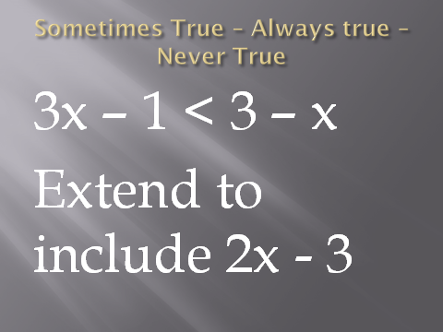



**Sometimes True, Always True, Never True.**

Could be used as a starter, main or plenary.

The idea would be to relate the algebra to the graphical representation but this could come later. You could use the first two expressions or all three. Students should realise that depending upon the numbers you put in there are different possibilities. These work out nicely as the intersections are all integer values.

**Good opportunity for group discussion. Good questioning techniques used here.**

